

**Excel Assignment - 9**

1. What are the different margins options and do we adjust the margins of the excel worksheet?

Answer: There are a few margin options available in Excel.

Select the worksheet or worksheets that you want to print.

**How to select worksheets**

* To select a single sheet:  
  Click the tab for the sheet that you want to print.  
  Sheet tabs   
  If you don't see the tab that you want, click the tab scrolling buttons to display the tab, and then click the tab.  
  Tab scrolling buttons
* To select two or more adjacent sheets:  
  Click the tab for the first sheet. Then hold down **Shift** and click the tab for the last sheet that you want to select.
* To select two or more non-adjacent sheets  
  Click the tab for the first sheet. Then hold down **Ctrl** while you click the tabs of the other sheets that you want to select.
* To select all sheets in a workbook:  
  Right-click on a sheet tab, and then click **Select All Sheets** from the shortcut menu.
* On the **Page Layout** tab, in the **Page Setup** group, click **Margins**.  
  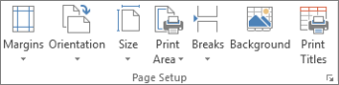
* Do one of the following:
  + To use predefined margins, click **Normal**, **Wide**, or **Narrow**.  
    **Tip:** If you previously used a custom margin setting, that setting is available as the **Last Custom Setting** option.
  + To specify custom page margins, click **Custom Margins** and then—in the **Top**, **Bottom**, **Left**, and **Right** boxes—enter the margin sizes that you want.
  + To set header or footer margins, click **Custom Margins**, and then enter a new margin size in the **Header** or **Footer** box. Setting either the header or footer margins changes the distance from the top edge of the paper to the header or from the bottom edge of the paper to the footer.

2. Set a background for your table created.

Answer: 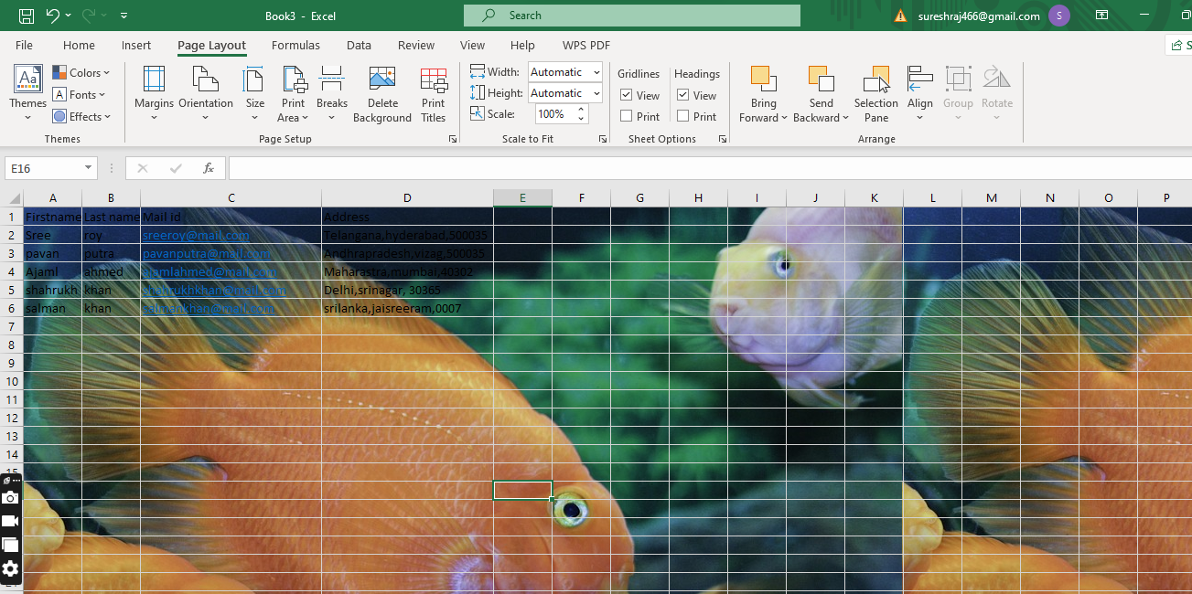

3. What is freeze panes and why do we use freeze panes? Give examples.

Answer:The Excel Freeze Panes option allows you to lock your columns and/or rows so that when you scroll down or over to view the rest of your sheet, the column and/or row will remain on the screen.

# Freeze Panes in Excel: Everything You Need to Know

[By Shruti M](https://www.simplilearn.com/authors/shruti-m)

Last updated on Feb 15, 2023

49968



## Table of Contents

[How to Freeze Top Row?](https://www.simplilearn.com/tutorials/excel-tutorial/how-to-freeze-panes-in-excel#how_to_freeze_top_row)[How to Unfreeze Panes?](https://www.simplilearn.com/tutorials/excel-tutorial/how-to-freeze-panes-in-excel#how_to_unfreeze_panes)[How to Freeze First Column?](https://www.simplilearn.com/tutorials/excel-tutorial/how-to-freeze-panes-in-excel#how_to_freeze_first_column)[How to Freeze Rows?](https://www.simplilearn.com/tutorials/excel-tutorial/how-to-freeze-panes-in-excel#how_to_freeze_rows)[Magic Freeze Button](https://www.simplilearn.com/tutorials/excel-tutorial/how-to-freeze-panes-in-excel#magic_freeze_button)

The [Excel](https://www.simplilearn.com/tutorials/excel-tutorial/excel-dashboard) Freeze Panes option allows you to lock your columns and/or rows so that when you scroll down or over to view the rest of your sheet, the column and/or row will remain on the screen.

Go to the View tab of a worksheet to select Freeze Panes, which locks specific rows and columns in place when you scroll to another area, or Split Panes, which creates separate windows of the same spreadsheet.

To freeze only the top row, execute the steps mentioned below:

1. In the windows group, go to the View tab, and click Freeze Panes.
2. Click Freeze Top Row.
3. 

4. What are the different features available within the Freeze Panes

Excel enables three methods to freeze the pane.

1. Freeze Pane
2. Freeze Top Row
3. Freeze First Column

## Properties of freeze pane

There are some points that you should be aware with them -

1. Once the worksheet is frozen using the freeze pane feature, you cannot unfreeze the worksheet by undoing the action. You have to unfreeze it manually.
2. If you freeze the top row, only the first row of the sheet will be frozen. You cannot freeze the column at the same time.
3. Similar to Point No. 2, if you freeze the first column using **Freeze First Column**, only the first column of the worksheet will be frozen. You cannot freeze the row at the same time.
4. If you apply the **Freeze Pane** option of Excel freeze pane feature, it can freeze the row and column simultaneously at the same time.

command?



5. Explain what the different sheet options present in excel are and what they do?

Answer : xcel sheet is one of the core elements of the workbook, there are multiple core options to perform from the Sheet Options. We can access various sheet options by using the following ways:

* Ribbon Sheet Options
* Right-click Sheet Options

Let us discuss each in detail:

### Ribbon Sheet Options

Excel has all the basic and advanced options present on its ribbon. Likewise, some quick sheet options are also present on the Excel ribbon and can be accessed by going to **Page Layout > Sheet Options.** It mainly has four toggle options: two for **Gridlines** and two for **Headings,** and they can be turned on and off by selecting and deselecting the checkboxes.

* **Gridlines:**
  + **View:** This option allows users to show/ hide gridlines within the active worksheet. Turning off this option removes the gridlines from the sheet and displays a blank Excel sheet.
  + **Print:** This option allows users to show/ hide gridlines on an Excel document that will be printed on paper.
* **Headings:**
  + **View:** This option allows users to show/ hide headings within the active worksheet. Turning off this option removes the headings from the current sheet's headers and footers.
  + **Print:** This option allows users to show/ hide headings on an Excel document, which is to be printed on paper.